**REAL TIME PLANT HEALTH MONITOR SYSTEM**

**A PROJECT REPORT**

***Submitted by***

**Tarit Jaiswal (19bai10153)**

**Vaibhav Joshi (19bai10072)**

**Manglam Tripathi (19bai10118)**

**Prithvi Raj Kothari (19bai10101)**

*in partial fulfilment for the award of the degree*

*of*

**BACHELOR OF TECHNOLOGY**

*in*

**PROGRAM OF STUDY**



**SCHOOL OF COMPUTING SCIENCE AND ENGINEERING**

**VIT BHOPAL UNIVERSITY**

**KOTHRIKALAN, SEHORE**

**MADHYA PRADESH – 466114**

**October 2020**

**VIT BHOPAL UNIVERSITY,KOTHRIKALAN, SEHORE**

**MADHYA PRADESH – 466114**

**BONAFIDE CERTIFICATE**

Certified that this project report titled “REAL TIME PLANT HEALTH MONITOR SYSTEM”is the bonafide work of “ Vaibhav Joshi (19bai10072) ,Manglam Tripathi (19bai10118) , Tarit Jaiswal (19bai10153) and Prithvi Raj Kothari (19bai10101) ”who carried out the project work under my supervision. Certified further that to the best of my knowledge the work reported here does not form part of any other project / research work on the basis of which a degree or award was conferred on an earlier occasion on this or any other candidate.

**PROGRAM CHAIR PROJECT GUIDE**

**Dr Sountharrajan S Dr L. Shakkeera,**

Senior Assistant Professor, Senior Assistant Professor

School of AI &ML division

VIT BHOPAL UNIVERSITY

The Project Viva-Voce Examination is held on _______________

**INTERNAL EXAMINER EXTERNAL EXAMINER**

**ACKNOWLEDGEMENT**

First and foremost I would like to thank the Lord Almighty for His presence and immense blessings throughout the project work.

I wish to express my heartfelt gratitude to Dr. S Sountharrajan , Programme Chair - B.Tech CSE Spl. in Artificial Intelligence and Machine Learning , School of Computing Science and Engineering,

for much of his valuable support encouragement in carrying out this work.

I would like to thank my internal guide Mr./Ms L. Shakeera for continually guiding and actively participating in my project, giving valuable suggestions to complete the project work.

I would like to thank all the technical and teaching staff of the School of CSE, who extended directly or indirectly all support.

Last, but not the least, I am deeply indebted to my parents who have been the greatest support while. I worked day and night for the project to make it a success.

**ABSTRACT**

This Basic idea of this project is to create an App based platform that can be easily used by the farmers to detect the disease their crop is suffering and to help them to use correct pesticide and fertilizers accordingly.

As most farmers are not educated enough to diagnose the if their crop is suffering from disease or whether their crop is healthy or not and if required then which pesticide or insecticide to use ?

We will achieve the goal by using the concept of deep learning to predict the disease , the plant is suffering.

A real time plant health monitor system that uses deep learning to diagnose the disease , plant is suffering from and give the information about its health status and suggest the farmer to use appropriate pesticide or insecticide if any.

**TABLE OF CONTENTS**

**1.** **INTRODUCTION** 5

1.1 INTRODUCTION

1.2 MOTIVATION FOR THE WORK6

1.3 PROJECT INCLUDING TECHNIQUES6

1.4 PROBLEM STATEMENT7

1.5 OBJECTIVE OF THE WORK7

1.6 ORGANIZATION OF THESIS7

**2. LITERATURE SURVEY** 8

**3. PROJECT PROCEDURE** 8

**4. WORK DONE** 8

**5. OBSERVATION** 9

**6. RESULT AND CONCLUSION** 9

6.1 Result

6.2 Conclusion

**7. Recommendation for future work** 11

**7.1 Hosting**

**7.2 Extending it for other disease categories.**

**7.3 Using more than one parameter to predict results.**

**7.4 Some drawbacks**

**8. REFERENCES** 12

**9. Appendix 1**………………………………………………………………………………………………………………………………………………………13

**10. Appendix 2**…………………………………………………………………………………………………………………………………………………….20

**11.Architecture Diagram** ……………………………………………………………………………………………………………………….27

# 

**LIST OF FIGURES**

|  |  |  |
| --- | --- | --- |
| Figure No. | Title | Page no. |
| Fig 1.1 | Simple vs deep neural networks | 7 |
| Fig 3.1 | CNN Architecture | 10 |
| Fig 3.2 | Visualization of CNN training | 11 |
| Fig 6.1 | Prediction on test data of different disease | 13 |
| Fig 10.1 | Snapshot of CNN model | 22 |
| Fig 10.2 | Snapshot of CNN model | 23 |
| Fig 10.3 | Snapshot of CNN model (graph) | 23 |
| Fig 10.4 | Snapshot of CNN model (output of test of model) | 24 |
| Fig 10.5 | Snapshot of website (home page part1) | 25 |
| Fig 10.6 | Snapshot of website (home page part2) | 25 |
| Fig 10.7 | Snapshot of website (Result page) | 26 |
| Fig 11.1 | System Architecture | 27 |

# **INTRODUCTION**

## **INTRODUCTION**

Farmers spend billions of dollars are on disease management, often without adequate technical support, resulting in poor disease control, pollution and harmful results. In addition, plant disease can devastate natural ecosystems, compounding environmental problems caused by habitat loss and poor land management.  
Crop losses tend to be greatest in tropical countries where environmental conditions are particularly favorable, incomes are low and knowledge and investments in crop health management are minimal. Disease losses can mean that communities become dependent on imported foods, often replacing a balanced diet with processed foods that create further health problems.  
Plant breeders have very successfully increased potential crop yields, however the impacts of crop breeding for resource-poor farmers have been disappointing. Much greater emphasis is required to address reasons for the gap between potential and actual yields achieved by farmers, and research that is focused on narrowing this gap.

So, we have come up with this web app which will be a great helping hand for them.

By using the idea of Deep learning and Machine learning to identify the disease the plant is suffering from.

**Deep learning** - Convolutional Neural Network (CNN or Conv Nets), It is well known for its widely used in applications of image and video recognition and also in recommender systems and Natural Language Processing (NLP). However, convolutional is more efficient because it reduces the number of parameters which makes different from other deep learning 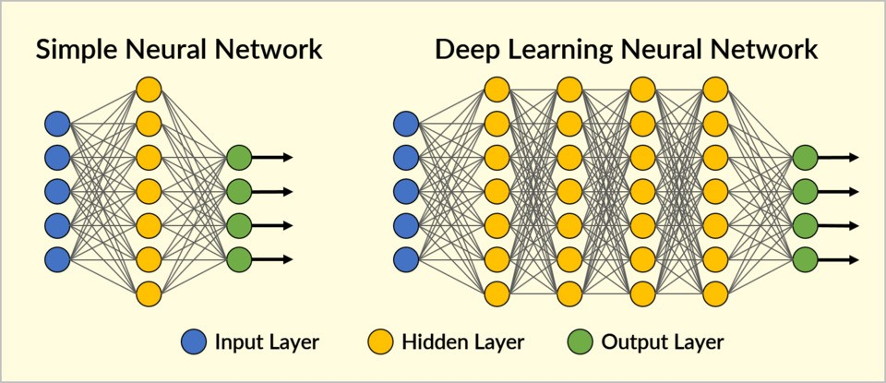

Fig 1.1

**Machine Learning**  - In recent days, in fast growing technological world, Machine Learning (ML) becomes popular among many of researchers, industries and government sectors. It is the contrivance of automating and cultivating the learning process of systems/computers based on their capabilities/understanding capabilities without being actually programmed by the human being’s assistance. The ML process starts with feeding the raw data as an input to train the machines by creating/building machine learning models or learning tasks. Using the different ML algorithms or methods uses the input data and targeted output builds ML models or ML tasks. The ML algorithms are based on type of data and kind of task which are trying to automate the machine learning models.  

## **1.2 MOTIVATION FOR THE WORK**

As most farmers are not educated enough to diagnose the disease their crop is suffering from or whether their crop is healthy or not and what pesticide or insecticide to use?  
A real time plant health monitor system that uses deep learning to diagnose the disease the plant is suffering from and give the information about its health status and suggest the farmer to use appropriate pesticide or insecticide if any.

## **1.3 PROJECT INCLUDING TECHNIQUES**

**Segmentation  -** The process of partitions the image pictures with comparable characteristics into different areas which comprises of each pixel values is called as segmentation. The areas should be heavily related to depicted objects or characteristics in order to be relevant and helpful for picture assessment and interpretation.

**Feature Extraction  -** The progression of which an initial data set is reduced into more manageable groups for processing the image data is known as feature extraction. The larger data set requires lot of processing time to compute the entire process. The feature extraction concepts include like traditional transformed and non-transformed single characteristics  and texture and graph descriptors methods.

**Classification -** In ML, the process to identify which set of categories are belongs to one group based on the relevant observations is called as classification method. The classification algorithm classifies the data into each corresponding classes. The plotted is processed as a function with band the result is a spectral signature or spectral response curve for that class.

**Prediction -** The method that usages the data mining and probability techniques to get the predicted outcomes is stated as predictive modeling in machine learning algorithms. Each model development is prepared with number of predictors, which are attributes or variable that are prospect methods active to manipulate the future results. Now a days, pe predictive modeling methods have many applications development in business and medical sectors.

## **1.4 PROBLEM STATEMENT**

The farmers are unable to track the overall status of their crops in their fields. Bring about a model for real-time identification of crops, weeds, pest attacks, and nutrient deficiency symptoms in the fields. This will be of great help for the farmers during this crisis.

## **1.5 OBJECTIVE OF THE WORK**

By using ML model through our app, it will be working like a software in  which by clicking a photo or scanning through our app ,it  will help us to detect the diseases and problems the plant is suffering. The photo will be uploaded to the app server and it will be processed on the cloud and it will return the required information.

A farmer can further know about the plant survival , pesticides , manures and fertilizers that should be given to it . It will improve the efficiency and profit margins for farmers.

## **ORGANIZATION OF THESIS**

In the introduction part we have mainly discussed about the technical agenda of our project .then in the literature survey we have given all the data and related work about farmers. In the project procedure part we have discussed about CNN and other languages then , in the work done part we have given our existing work followed with the observed data in the observation section and in recommendations and future work we have discussed about our proposed system and some future works , then in references section we have submitted our references through which we gathered information and other data.

* 1. **SUMMARY**

From the moment a seed is planted through to harvest, crops need to be protected from weeds, insects and diseases as well as droughts and floods, heat and cold. Farmers work Hard day and night to protect their crops from diseases yet these superheroes sometimes fail to identify the disease their crop is suffering.

So, we have come up with this web app which will be a great helping hand for them.

This Basic idea of this project is to create a User-Friendly Web App that can be easily used by the farmers to detect the disease their crop is suffering and to help them to use correct pesticide and fertilizers accordingly. Which will improve the overall yield of the Crop And it will Help the farmers to increase their income by minimizing their losses. By using ML model through our web app Farmers will be able detect the diseases and problems the plant is suffering and can use the required fertilizers and pesticides.

# **2. LITERATURE SURVEY**

Research work on our project includes the data of farmers and plant diseases. Farmers which are detecting disease of plant through their naked eye and are confused which fertilizer to use and they aren’t enough educated too. So , on the development side of our project of (real time plant health monitor system ) we are using deep learning and machine learning to diagnose the disease plant is suffering from and to suggest appropriate insecticide and pesticides to the farmer for that particular diseased crop. The least requirements of using this app is just smartphone that should have 1 GB of ram with a camera and internet. We are having a cloud storage to collect all data of farmers. We are using CNN(convolutional neural network) deep learning model in this project .it is widely used in applications of image and video recognition and also in recommender systems and natural language processing (NLP).

# **3. PROJECT PROCEDURE**

**Gathering Data** - due to limitation of such kind of datasets we will initially train the model for Potato and Tomato plants. By using 30,000 labelled images that we gathered from https://www.kaggle.com/datasets.

**Building CNN:** Next step in this process is building a CNN we will be using python and its libraries like TensorFlow and keras (keras is high level API to build and train deep learning models)

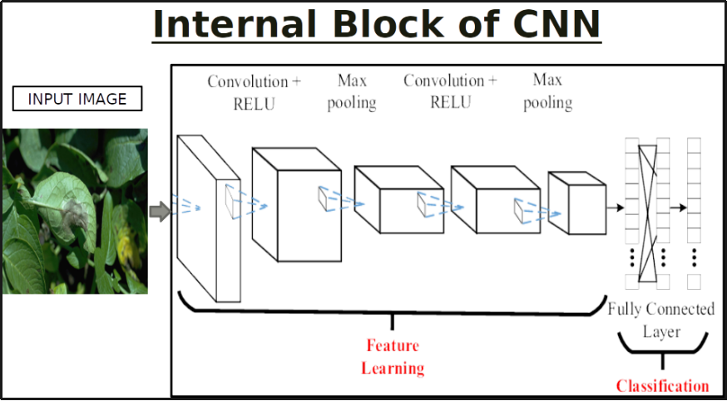

Fig 3.1

**Training the model:** We can train our model either on online cloud computer like google colab or on a powerful desktop. (one having a graphics card).

After training and saving the model it is ready to predict the results.

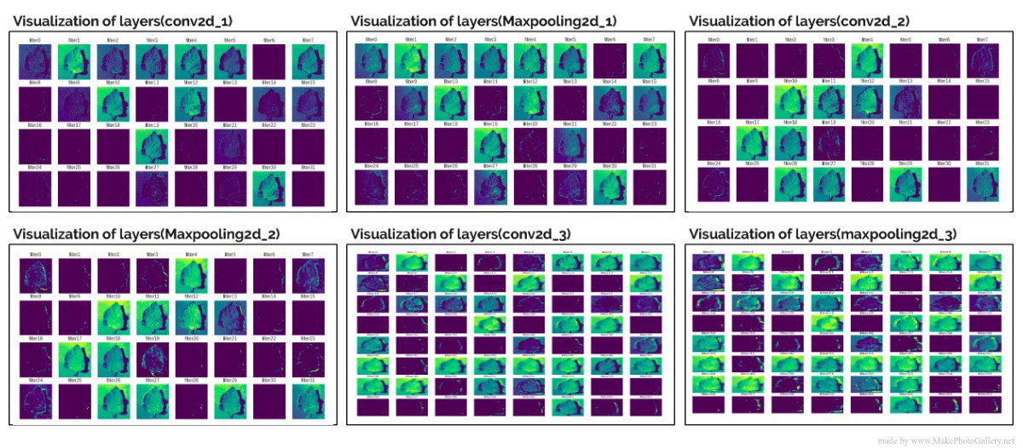

Fig 3.2

**For App**: Presently its web-based application but in future we would be making an app in which we will be using KOTLIN and android studio to create a user-friendly app for farmers. It will provide two options either upload the pic of the leaf of the plant using gallery or to scan the leaf using the camera. The image will be further sent to our app server where it will be passed to our deep learning model which will process it and predict the result accordingly and the results will be displayed on the app.

# **4. WORK DONE**

The Project involves the use of Deep Learning

to predict the diseases that are difficult for any farmer's eye to detect

We have created a Deep learning Model Which use image processing libraries like TensorFlow and keras to predict the disease a crop is suffering. Currently due to Lack of dataset we have trained our model for Potato and Tomato Crop only but we will be extending our support for Corn Maze and Barley Too in near future.

We have used 11 Layers of Neurons (of an artificial Neural network)

to process the image and predict the result.

we were able to get 96% Accuracy while training and testing Process.

we have created a small database using sqllite3 in python which contains the information about the symptoms , causes , pathogens , and remedies of the required disease.

Currently our model efficiently detects the diseases within 15 categories for a tomato and potato plant and we can increase it when more data set will be available.

Now About our Interface:

Due to limitation of time we have created a web app which can be converted to a mobile app with slight modifications using android studio and flutter.

we have used HTML, CSS, and JavaScript to create a user-friendly web interface that can be accessed on mobile as well as a laptop. We have provided the facility of chat Bot too to make it convenient for farmers.

Hosting :initially we have planned to host our web app on Heroku which provides free hosting we will be using it as our server and later we could even Buy a small server for this.

# **5. OBSERVATION**

As agriculture struggles to support the rapidly growing global population, plant disease reduces the production and quality of food, fiber and biofuel crops. Losses may be catastrophic or chronic, but on average account for 42% of the production of the six most important food crops.

We observed that farmers don’t have high specs smartphones so we have created a light web app which does not require much hardware requirements.

As most farmers are ill-literate hence we have tried to keep things clear and simple we have tried to keep our Platform clean and Simple.

# **6. RESULT AND CONCLUSION**

## **6.1 RESULT**

When a user uploads an image of a plant using a smart device which have access to internet then that image is sent to our servers and passed on to the pre trained deep learning model. Which uses 12 layers of neurons to process the image and predict the accurate results.

## The image will be processed in different stages by using the concept of Artificial Neural Networks.

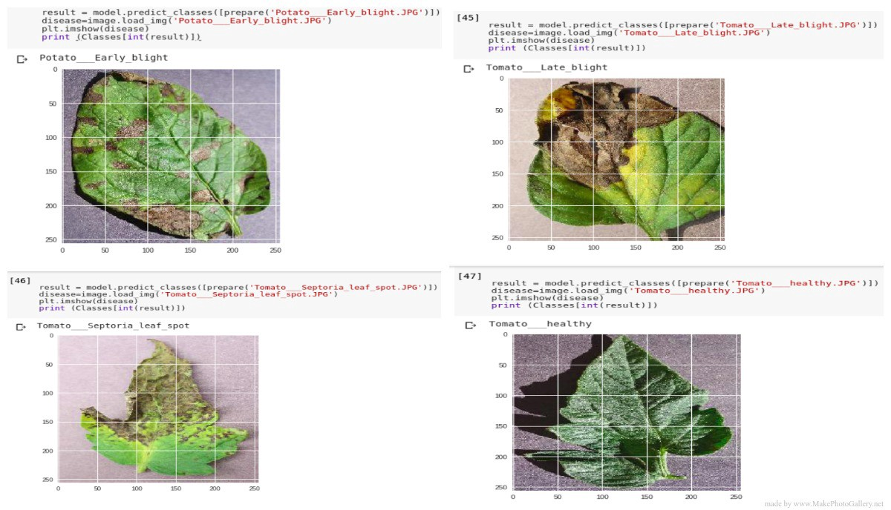

Fig 6.1

## **6.2. CONCLUSION**

Plant Diseases are major food threats that should have to overcome before it leads to further loss of the entire field. But, often framers unable to distinguish between similar symptoms but ace different diseases. This will mislead to wrong or overdosage of fertilizers. Here, we employ Convolutional Neural Network(CNN) multiple layers of ANN called Deep Learning Algorithms to reduce this loss and guide farmers with video lessons. This can be done through mobile App “Not all farmers but some do use it.”

# **7. Recommendation for future work**

# **7.1 HOSTING**

# Presently we are hosting in our local machines but in future we are thinking to put it on some server.

Preferably on Heroku which is a free web hosting platform.

**7.2 Extending it for other disease categories.**

Currently it is able to predict results for tomato and potato plants only but in future we are going it to extend it for other plants too by using a larger dataset of 1 lakh images.

# **7.3 Using More Than One Parameters to predict Results.**

We have planned to use other parameters like type of soil and weather conditions to provide more accurate results combined with the image recognition system.

# **7.4 DRAWBACKS IN OUR EXISTING SYSTEM**

• The Algorithm works well with single leaf at a time, so try uploading images with one leaf.

• The Algorithm won't predict when more leaves in one image, it is good at predicting one leaf .

# • We cannot say that every farmer is privileged with smartphone with camera and a ram of 1 gb

# • Internet issues in some areas and villages

# • Lack of education and how to operate such devices

We will be working to improve these things.

# **8. REFERENCES**

Wikipedia.com

Kaggle.com

google.com

And some books on keras and machine learning language like – deep learning with keras by – Sujit pal.

**Appendix 1**

**Code**

**You can find the complete source code on the link given below.**

GitHub Repository: <https://github.com/cgincognito01/plant-health>

We are putting just part of a code here as the whole code is of 13000 lines that you can see on our GitHub repository mentioned above.

table > thread > tr > th,

.table > body > tr > th,

.table > tfoot > tr > th,

.table > thead > tr > td,

.table > tbody > tr > td,

.table > tfoot > tr > td {

padding: 8px;

line-height: 1.42857143;

vertical-align: top;

border-top: 1px solid #ddd;

}

.table > thead > tr > th {

vertical-align: bottom;

border-bottom: 2px solid #ddd;

}

.table > caption + thead > tr:first-child > th,

.table > colgroup + thead > tr:first-child > th,

.table > thead:first-child > tr:first-child > th,

.table > caption + thead > tr:first-child > td,

.table > colgroup + thead > tr:first-child > td,

.table > thead:first-child > tr:first-child > td {

border-top: 0;

}

.table > tbody + tbody {

border-top: 2px solid #ddd;

}

.table .table {

background-color: #fff;

}

.table-condensed > thead > tr > th,

.table-condensed > tbody > tr > th,

.table-condensed > tfoot > tr > th,

.table-condensed > thead > tr > td,

.table-condensed > tbody > tr > td,

.table-condensed > tfoot > tr > td {

padding: 5px;

}

.table-bordered {

border: 1px solid #ddd;

}

.table-bordered > thead > tr > th,

.table-bordered > tbody > tr > th,

.table-bordered > tfoot > tr > th,

.table-bordered > thead > tr > td,

.table-bordered > tbody > tr > td,

.table-bordered > tfoot > tr > td {

border: 1px solid #ddd;

}

.table-bordered > thead > tr > th,

.table-bordered > thead > tr > td {

border-bottom-width: 2px;

}

.table-striped > tbody > tr:nth-of-type(odd) {

background-color: #f9f9f9;

}

.table-hover > tbody > tr:hover {

background-color: #f5f5f5;

}

table col[class*="col-"] {

position: static;

float: none;

display: table-column;

}

table td[class*="col-"],

table th[class*="col-"] {

position: static;

float: none;

display: table-cell;

}

.table > thead > tr > td.active,

.table > tbody > tr > td.active,

.table > tfoot > tr > td.active,

.table > thead > tr > th.active,

.table > tbody > tr > th.active,

.table > tfoot > tr > th.active,

.table > thead > tr.active > td,

.table > tbody > tr.active > td,

.table > tfoot > tr.active > td,

.table > thead > tr.active > th,

.table > tbody > tr.active > th,

.table > tfoot > tr.active > th {

background-color: #f5f5f5;

}

.table-hover > tbody > tr > td.active:hover,

.table-hover > tbody > tr > th.active:hover,

.table-hover > tbody > tr.active:hover > td,

.table-hover > tbody > tr:hover > .active,

.table-hover > tbody > tr.active:hover > th {

background-color: #e8e8e8;

}

.table > thead > tr > td.success,

.table > tbody > tr > td.success,

.table > tfoot > tr > td.success,

.table > thead > tr > th.success,

.table > tbody > tr > th.success,

.table > tfoot > tr > th.success,

.table > thead > tr.success > td,

.table > tbody > tr.success > td,

.table > tfoot > tr.success > td,

.table > thead > tr.success > th,

.table > tbody > tr.success > th,

.table > tfoot > tr.success > th {

background-color: #dff0d8;

}

.table-hover > tbody > tr > td.success:hover,

.table-hover > tbody > tr > th.success:hover,

.table-hover > tbody > tr.success:hover > td,

.table-hover > tbody > tr:hover > .success,

.table-hover > tbody > tr.success:hover > th {

background-color: #d0e9c6;

}

.table > thead > tr > td.info,

.table > tbody > tr > td.info,

.table > tfoot > tr > td.info,

.table > thead > tr > th.info,

.table > tbody > tr > th.info,

.table > tfoot > tr > th.info,

.table > thead > tr.info > td,

.table > tbody > tr.info > td,

.table > tfoot > tr.info > td,

.table > thead > tr.info > th,

.table > tbody > tr.info > th,

.table > tfoot > tr.info > th {

background-color: #d9edf7;

}

.table-hover > tbody > tr > td.info:hover,

.table-hover > tbody > tr > th.info:hover,

.table-hover > tbody > tr.info:hover > td,

.table-hover > tbody > tr:hover > .info,

.table-hover > tbody > tr.info:hover > th {

background-color: #c4e3f3;

}

.table > thead > tr > td.warning,

.table > tbody > tr > td.warning,

.table > tfoot > tr > td.warning,

.table > thead > tr > th.warning,

.table > tbody > tr > th.warning,

.table > tfoot > tr > th.warning,

.table > thead > tr.warning > td,

.table > tbody > tr.warning > td,

.table > tfoot > tr.warning > td,

.table > thead > tr.warning > th,

.table > tbody > tr.warning > th,

.table > tfoot > tr.warning > th {

background-color: #fcf8e3;

}

.table-hover > tbody > tr > td.warning:hover,

.table-hover > tbody > tr > th.warning:hover,

.table-hover > tbody > tr.warning:hover > td,

.table-hover > tbody > tr:hover > .warning,

.table-hover > tbody > tr.warning:hover > th {

background-color: #faf2cc;

}

.table > thead > tr > td.danger,

.table > tbody > tr > td.danger,

.table > tfoot > tr > td.danger,

.table > thead > tr > th.danger,

.table > tbody > tr > th.danger,

.table > tfoot > tr > th.danger,

.table > thead > tr.danger > td,

.table > tbody > tr.danger > td,

.table > tfoot > tr.danger > td,

.table > thead > tr.danger > th,

.table > tbody > tr.danger > th,

.table > tfoot > tr.danger > th {

background-color: #f2dede;

}

.table-hover > tbody > tr > td.danger:hover,

.table-hover > tbody > tr > th.danger:hover,

.table-hover > tbody > tr.danger:hover > td,

.table-hover > tbody > tr:hover > .danger,

.table-hover > tbody > tr.danger:hover > th {

background-color: #ebcccc;

}

.table-responsive {

overflow-x: auto;

min-height: 0.01%;

}

@media screen and (max-width: 767px) {

.table-responsive {

width: 100%;

margin-bottom: 13.5px;

overflow-y: hidden;

-ms-overflow-style: -ms-autohiding-scrollbar;

border: 1px solid #ddd;

}

.table-responsive > .table {

margin-bottom: 0;

}

.table-responsive > .table > thead > tr > th,

.table-responsive > .table > tbody > tr > th,

.table-responsive > .table > tfoot > tr > th,

.table-responsive > .table > thead > tr > td,

.table-responsive > .table > tbody > tr > td,

.table-responsive > .table > tfoot > tr > td {

white-space: nowrap;

}

.table-responsive > .table-bordered {

border: 0;

}

.table-responsive > .table-bordered > thead > tr > th:first-child,

.table-responsive > .table-bordered > tbody > tr > th:first-child,

.table-responsive > .table-bordered > tfoot > tr > th:first-child,

.table-responsive > .table-bordered > thead > tr > td:first-child,

.table-responsive > .table-bordered > tbody > tr > td:first-child,

.table-responsive > .table-bordered > tfoot > tr > td:first-child {

border-left: 0;

}

.table-responsive > .table-bordered > thead > tr > th:last-child,

.table-responsive > .table-bordered > tbody > tr > th:last-child,

.table-responsive > .table-bordered > tfoot > tr > th:last-child,

.table-responsive > .table-bordered > thead > tr > td:last-child,

.table-responsive > .table-bordered > tbody > tr > td:last-child,

.table-responsive > .table-bordered > tfoot > tr > td:last-child {

border-right: 0;

}

.table-responsive > .table-bordered > tbody > tr:last-child > th,

.table-responsive > .table-bordered > tfoot > tr:last-child > th,

.table-responsive > .table-bordered > tbody > tr:last-child > td,

.table-responsive > .table-bordered > tfoot > tr:last-child > td {

border-bottom: 0;

}

}

fieldset {

padding: 0;

margin: 0;

border: 0;

min-width: 0;

}

legend {

display: block;

width: 100%;

padding: 0;

margin-bottom: 18px;

font-size: 19.5px;

line-height: inherit;

color: #333333;

border: 0;

border-bottom: 1px solid #e5e5e5;

}

label {

display: inline-block;

max-width: 100%;

margin-bottom: 5px;

font-weight: bold;

}

input[type="search"] {

-webkit-box-sizing: border-box;

-moz-box-sizing: border-box;

box-sizing: border-box;

}

input[type="radio"],

input[type="checkbox"] {

margin: 4px 0 0;

margin-top: 1px \9;

line-height: normal;

}

input[type="file"] {

display: block;

}

input[type="range"] {

display: block;

width: 100%;

}

select[multiple],

select[size] {

height: auto;

}

input[type="file"]:focus,

input[type="radio"]:focus,

input[type="checkbox"]:focus {

outline: 5px auto -webkit-focus-ring-color;

outline-offset: -2px;

}

output {

display: block;

padding-top: 7px;

font-size: 13px;

line-height: 1.42857143;

color: #555555;

}

.form-control {

display: block;

width: 100%;

height: 32px;

padding: 6px 12px;

font-size: 13px;

line-height: 1.42857143;

color: #555555;

background-color: #fff;

background-image: none;

border: 1px solid #ccc;

border-radius: 2px;

-webkit-box-shadow: inset 0 1px rgba(0, 0, 0, 0.075);

box-shadow: inset 0 1px rgba(0, 0, 0, 0.075);

-webkit-transition: border-color ease-in-out .15s, box-shadow ease-in-out .15s;

-o-transition: border-color ease-in-out .15s, box-shadow ease-in-out .15s;

transition: border-color ease-in-out .15s, box-shadow ease-in-out .15s;

}

.form-control:focus {

border-color: #66afe9;

outline: 0;

-webkit-box-shadow: inset 0 1px rgba(0,0,0,.075), 0 0 8px rgba(102, 175, 233, 0.6);

box-shadow: inset 0 1px rgba(0,0,0,.075), 0 0 8px rgba(102, 175, 233, 0.6);

}

.form-control::-moz-placeholder {

color: #999;

opacity: 1;

}

.form-control:-ms-input-placeholder {

color: #999;

}

.form-control::-webkit-input-placeholder {

color: #999;

}

.form-control::-ms-expand {

border: 0;

background-color: transparent;

}

.form-control[disabled],

.form-control[readonly],

fieldset[disabled] .form-control {

background-color: #eeeeee;

opacity: 1;

}

.form-control[disabled],

fieldset[disabled] .form-control {

cursor: not-allowed;

}

textarea.form-control {

height: auto;

}

input[type="search"] {

-webkit-appearance: none;

}

@media screen and (-webkit-min-device-pixel-ratio: 0) {

input[type="date"].form-control,

input[type="time"].form-control,

input[type="datetime-local"].form-control,

input[type="month"].form-control {

line-height: 32px;

}

input[type="date"].input-sm,

input[type="time"].input-sm,

input[type="datetime-local"].input-sm,

input[type="month"].input-sm,

.input-group-sm input[type="date"],

.input-group-sm input[type="time"],

.input-group-sm input[type="datetime-local"],

.input-group-sm input[type="month"] {

line-height: 30px;

}

input[type="date"].input-lg,

input[type="time"].input-lg,

input[type="datetime-local"].input-lg,

input[type="month"].input-lg,

.input-group-lg input[type="date"],

.input-group-lg input[type="time"],

.input-group-lg input[type="datetime-local"],

.input-group-lg input[type="month"] {

line-height: 45px;

}

}

.form-group {

margin-bottom: 15px;

}

.radio,

.checkbox {

position: relative;

display: block;

margin-top: 10px;

margin-bottom: 10px;

}

.radio label,

.checkbox label {

min-height: 18px;

padding-left: 20px;

margin-bottom: 0;

font-weight: normal;

cursor: pointer;

}

**Appendix 2**

**Screenshots**

Screenshot of machine learning Model Used in our P

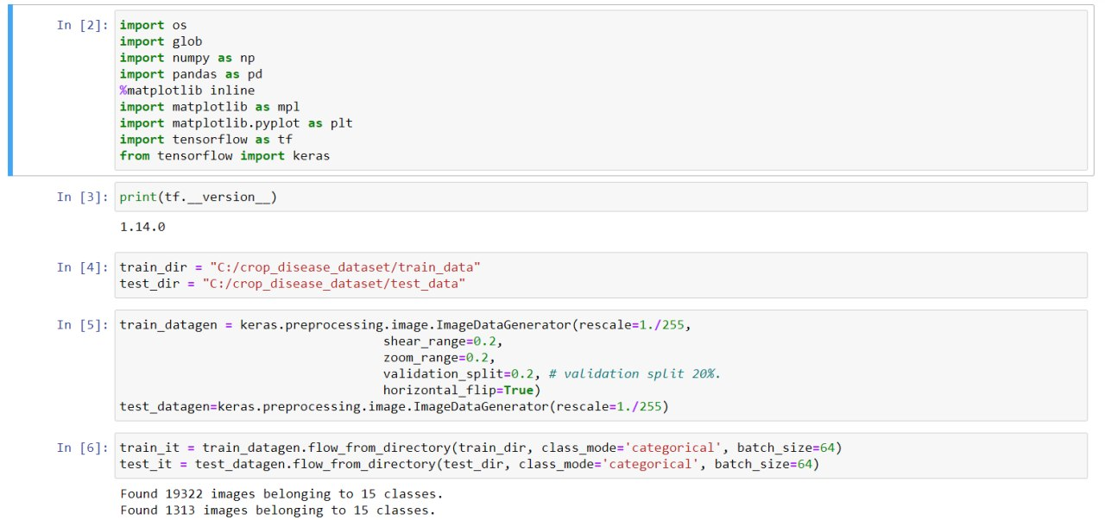

**Fig 10.1**

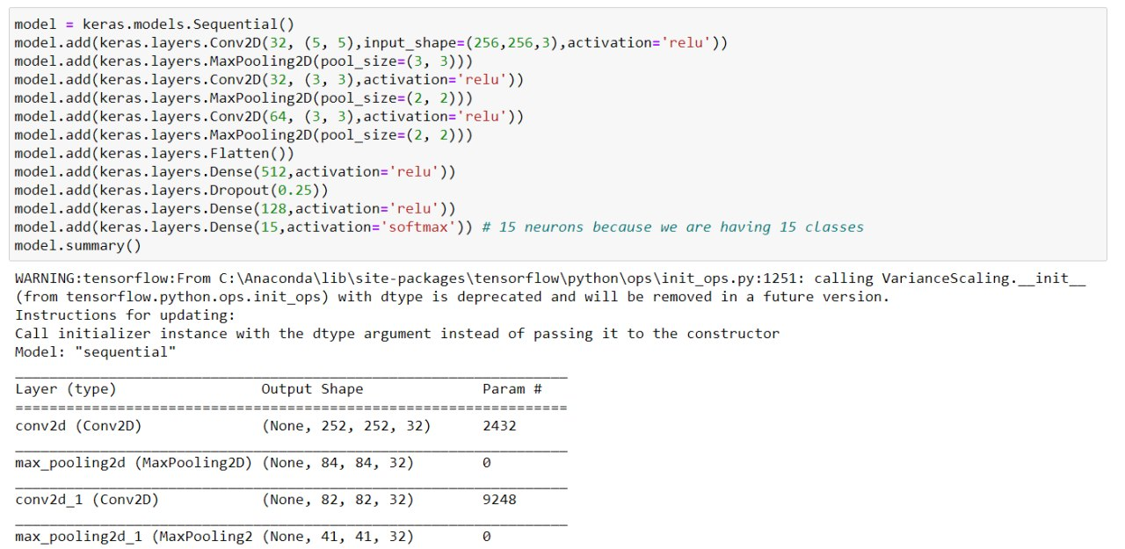

Fig 10.2

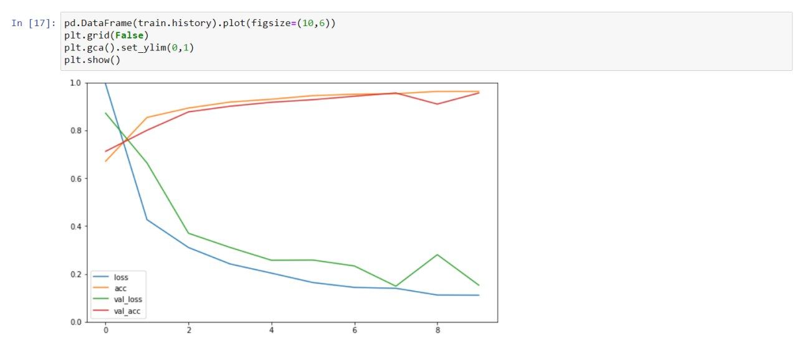

Fig 10.3

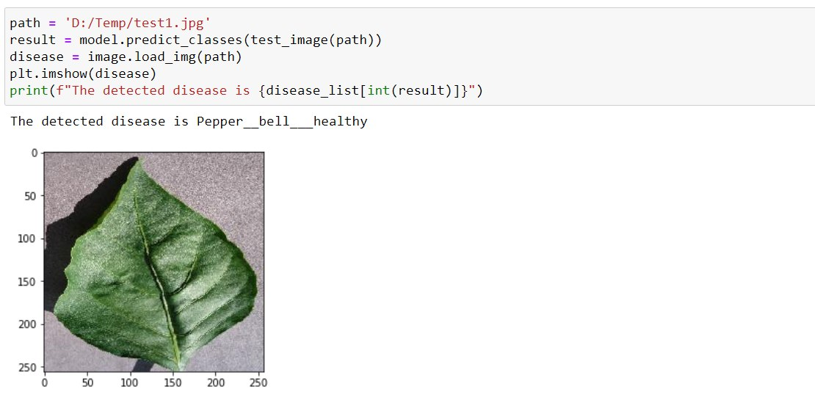

Fig 10.4

Front-end Website

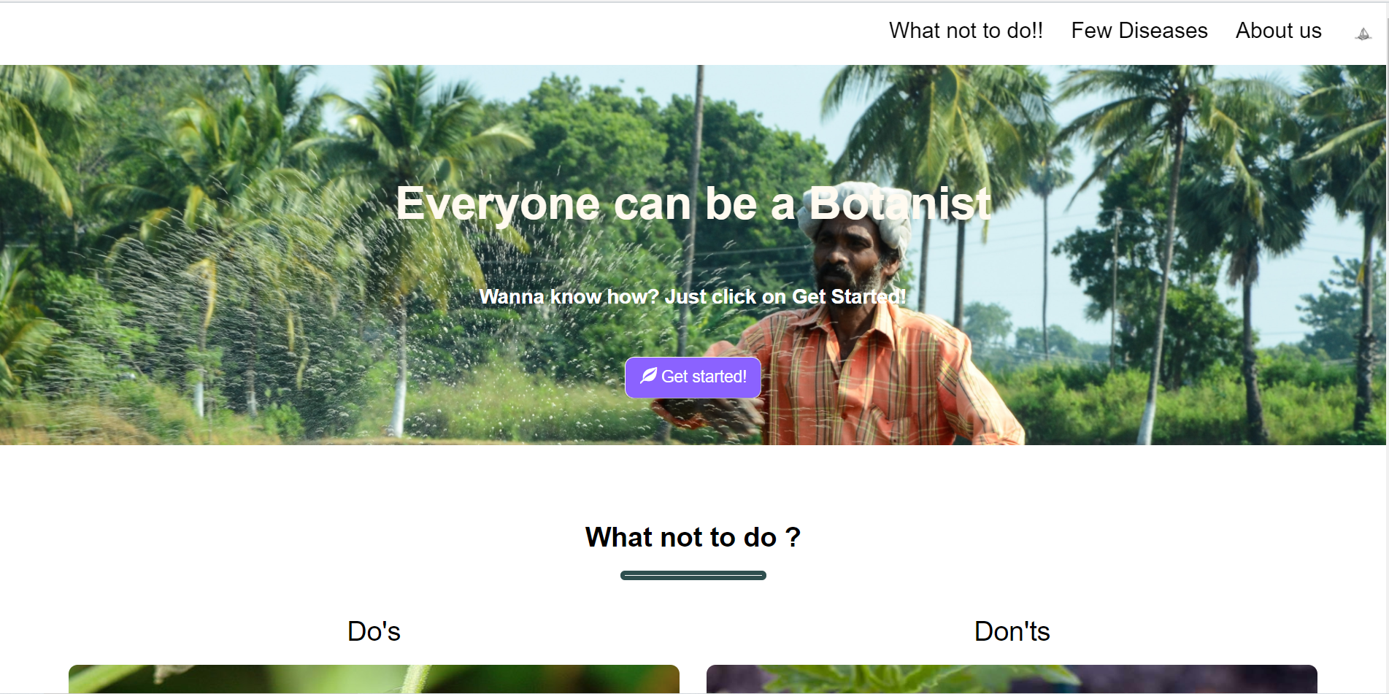

Fig 10.5

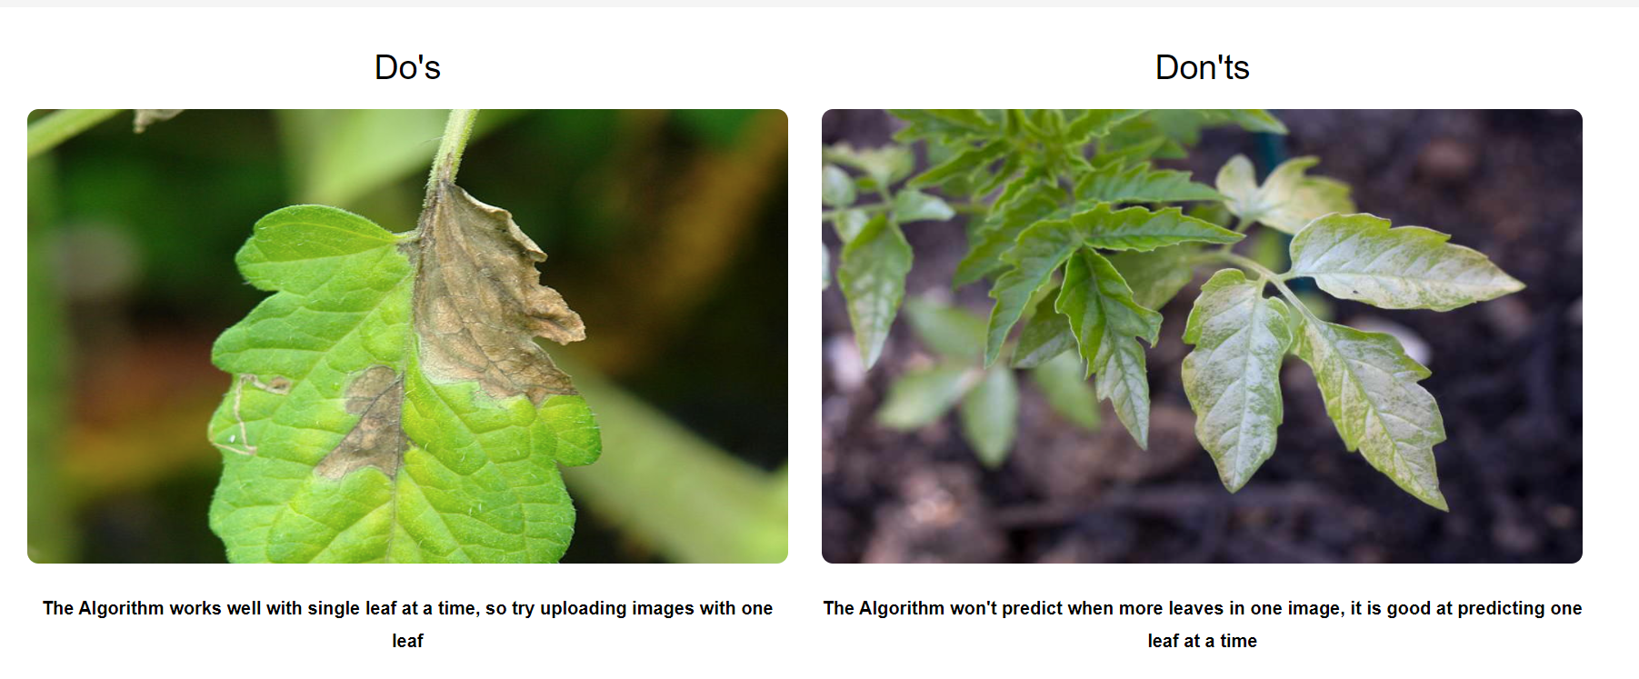

Fig 10.6

Result Page

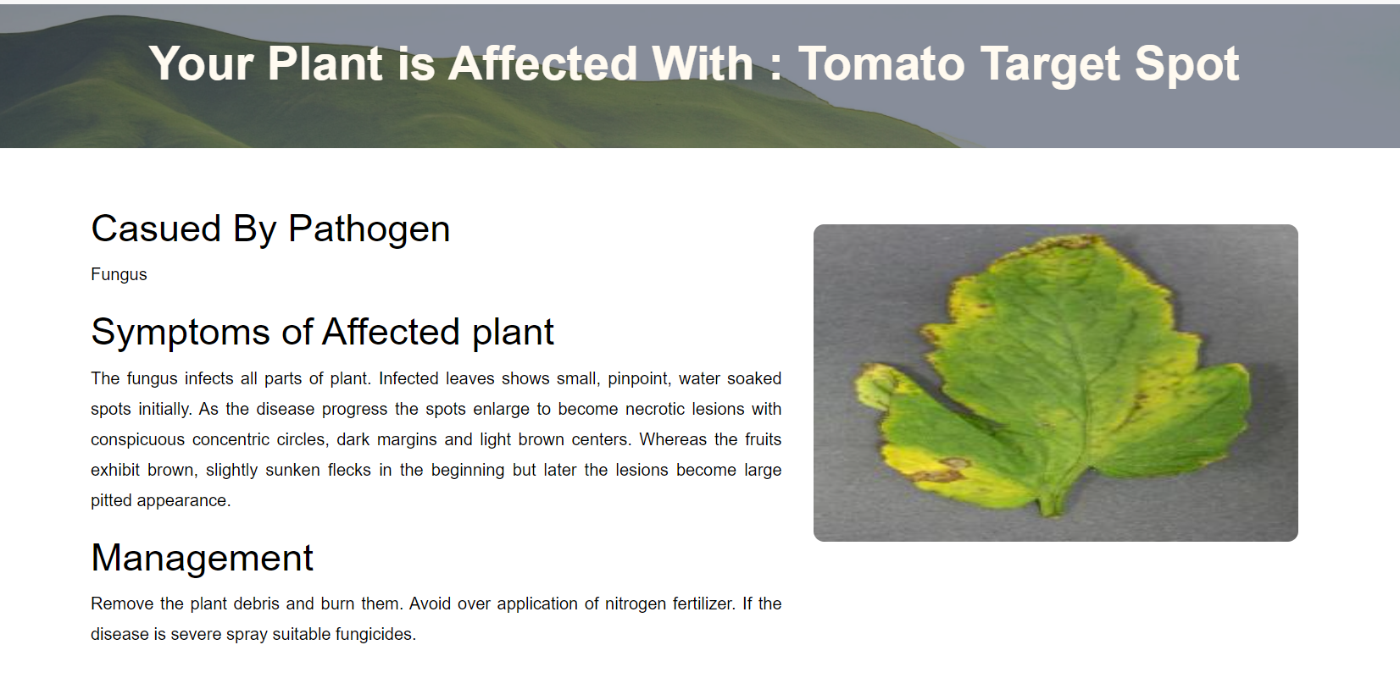

Fig 10.7

# **11. Architecture Diagram**

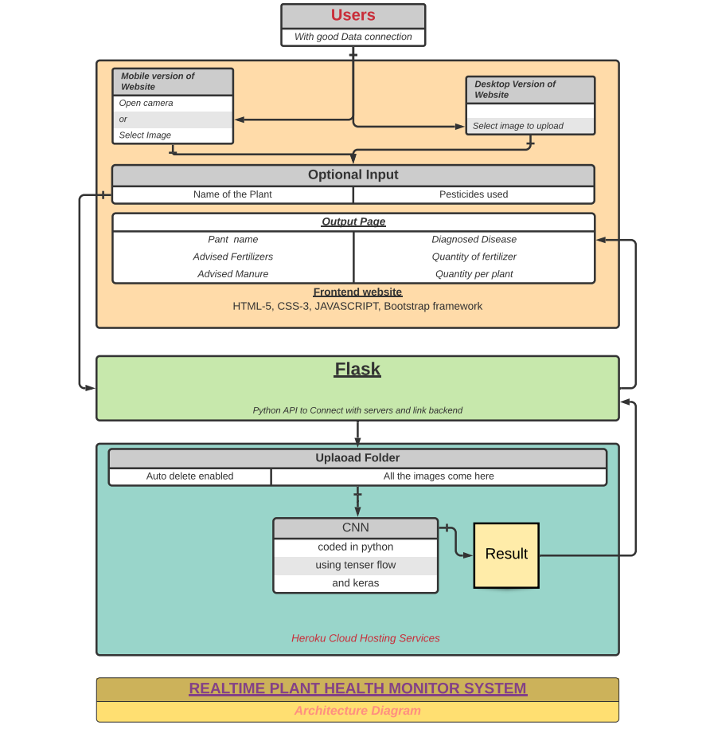

Fig 11.1